**NRF controlled home automation**

**Introduction**

In this home automation circuit using Arduino microcontroller board which can control up to 10 devices independently and wirelessly at 2.4 GHz band with range of 1 KM. We are utilizing the same 2.4 GHz band which an ordinary Wi-Fi router also utilizes for connecting smartphones and computer to internet, but we are not using any router or modem in this project

.We are using point to point communication, there will be a receiver circuit which controls 10 relays and a remote control circuit with 10 buttons for controlling each relays independently. A LED is provided with remote which will lights up only if the receiver actually receives the signal from remote circuit.

If the receiver is out of range the LED won’t glow when a button is pressed, by this you can know whether you really switched your connected device or not.

**Components**

* 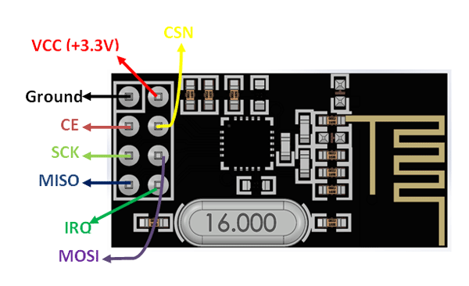Arduino nano(2)
* NRF24L01(2)
* Relay(10)
* Switches(
* Battery and battery holder
* Switch
* Breadboard & connecting wires

**Application**

* Used in wireless remote control
* Used in wireless data transfer

**Objective**

During this activity ,you will help students to achieve following objectives

1. Understanding the principle and operation of NRF24L01 RF module
2. Design algorithm and flowchart for home automation.
3. Programming NRF24L01 RF module using Arduino nano
4. Interfacing NRF24L01 RF module with Arduino nano

**Program**

**Transmitter code :**

#include <RF24.h>

#include<SPI.h>

RF24 **radio**(**9**,**10**);

**const** byte address[][**6**] = {"00001", "00002"};

**const** **int** ip1 = **2**;

**const** **int** ip2 = **3**;

**const** **int** ip3 = **4**;

**const** **int** ip4 = **5**;

**const** **int** ip5 = **6**;

**const** **int** ip6 = **7**;

**const** **int** ip7 = **8**;

**const** **int** ip8 = A0;

**const** **int** ip9 = A1;

**const** **int** ip10 = A2;

**const** **int** buzzer = A3;

**char** buzzchar[**32**] = "";

**const** **char** constbuzzer[**32**] = "buzz";

**const** **char** button1[**32**] = "activate_1";

**const** **char** button2[**32**] = "activate_2";

**const** **char** button3[**32**] = "activate_3";

**const** **char** button4[**32**] = "activate_4";

**const** **char** button5[**32**] = "activate_5";

**const** **char** button6[**32**] = "activate_6";

**const** **char** button7[**32**] = "activate_7";

**const** **char** button8[**32**] = "activate_8";

**const** **char** button9[**32**] = "activate_9";

**const** **char** button10[**32**] = "activate_10";

**void** **setup**()

{

pinMode(ip1, INPUT);

pinMode(ip2, INPUT);

pinMode(ip3, INPUT);

pinMode(ip4, INPUT);

pinMode(ip5, INPUT);

pinMode(ip6, INPUT);

pinMode(ip7, INPUT);

pinMode(ip8, INPUT);

pinMode(ip9, INPUT);

pinMode(ip10, INPUT);

pinMode(buzzer, OUTPUT);

digitalWrite(ip1, HIGH);

digitalWrite(ip2, HIGH);

digitalWrite(ip3, HIGH);

digitalWrite(ip4, HIGH);

digitalWrite(ip5, HIGH);

digitalWrite(ip6, HIGH);

digitalWrite(ip7, HIGH);

digitalWrite(ip8, HIGH);

digitalWrite(ip9, HIGH);

digitalWrite(ip10, HIGH);

radio.begin();

radio.openWritingPipe(address[**1**]);

radio.openReadingPipe(**1**, address[**0**]);

radio.setChannel(**100**);

radio.setDataRate(RF24_250KBPS);

radio.setPALevel(RF24_PA_MAX);

radio.stopListening();

}

**void** **loop**()

{

**if**(digitalRead(ip1) == LOW)

{

radio.write(&button1, **sizeof**(button1));

radio.startListening();

**while**(!radio.available());

radio.read(&buzzchar, **sizeof**(buzzchar));

**if**(strcmp(buzzchar,constbuzzer) == **0**)

{

digitalWrite(buzzer, HIGH);

delay(**500**);

digitalWrite(buzzer,LOW);

}

radio.stopListening();

}

**if**(digitalRead(ip2) == LOW)

{

radio.write(&button2, **sizeof**(button2));

radio.startListening();

**while**(!radio.available());

radio.read(&buzzchar, **sizeof**(buzzchar));

**if**(strcmp(buzzchar,constbuzzer) == **0**)

{

digitalWrite(buzzer, HIGH);

delay(**500**);

digitalWrite(buzzer,LOW);

}

radio.stopListening();

}

**if**(digitalRead(ip3) == LOW)

{

radio.write(&button3, **sizeof**(button3));

radio.startListening();

**while**(!radio.available());

radio.read(&buzzchar, **sizeof**(buzzchar));

**if**(strcmp(buzzchar,constbuzzer) == **0**)

{

digitalWrite(buzzer, HIGH);

delay(**500**);

digitalWrite(buzzer,LOW);

}

radio.stopListening();

}

**if**(digitalRead(ip4) == LOW)

{

radio.write(&button4, **sizeof**(button4));

radio.startListening();

**while**(!radio.available());

radio.read(&buzzchar, **sizeof**(buzzchar));

**if**(strcmp(buzzchar,constbuzzer) == **0**)

{

digitalWrite(buzzer, HIGH);

delay(**500**);

digitalWrite(buzzer,LOW);

}

radio.stopListening();

}

**if**(digitalRead(ip5) == LOW)

{

radio.write(&button5, **sizeof**(button5));

radio.startListening();

**while**(!radio.available());

radio.read(&buzzchar, **sizeof**(buzzchar));

**if**(strcmp(buzzchar,constbuzzer) == **0**)

{

digitalWrite(buzzer, HIGH);

delay(**500**);

digitalWrite(buzzer,LOW);

}

radio.stopListening();

}

**if**(digitalRead(ip6) == LOW)

{

radio.write(&button6, **sizeof**(button6));

radio.startListening();

**while**(!radio.available());

radio.read(&buzzchar, **sizeof**(buzzchar));

**if**(strcmp(buzzchar,constbuzzer) == **0**)

{

digitalWrite(buzzer, HIGH);

delay(**500**);

digitalWrite(buzzer,LOW);

}

radio.stopListening();

}

**if**(digitalRead(ip7) == LOW)

{

radio.write(&button7, **sizeof**(button7));

radio.startListening();

**while**(!radio.available());

radio.read(&buzzchar, **sizeof**(buzzchar));

**if**(strcmp(buzzchar,constbuzzer) == **0**)

{

digitalWrite(buzzer, HIGH);

delay(**500**);

digitalWrite(buzzer,LOW);

}

radio.stopListening();

}

**if**(digitalRead(ip8) == LOW)

{

radio.write(&button8, **sizeof**(button8));

radio.startListening();

**while**(!radio.available());

radio.read(&buzzchar, **sizeof**(buzzchar));

**if**(strcmp(buzzchar,constbuzzer) == **0**)

{

digitalWrite(buzzer, HIGH);

delay(**500**);

digitalWrite(buzzer,LOW);

}

radio.stopListening();

}

**if**(digitalRead(ip9) == LOW)

{

radio.write(&button9, **sizeof**(button9));

radio.startListening();

**while**(!radio.available());

radio.read(&buzzchar, **sizeof**(buzzchar));

**if**(strcmp(buzzchar,constbuzzer) == **0**)

{

digitalWrite(buzzer, HIGH);

delay(**500**);

digitalWrite(buzzer,LOW);

}

radio.stopListening();

}

**if**(digitalRead(ip10) == LOW)

{

radio.write(&button10, **sizeof**(button10));

radio.startListening();

**while**(!radio.available());

radio.read(&buzzchar, **sizeof**(buzzchar));

**if**(strcmp(buzzchar,constbuzzer) == **0**)

{

digitalWrite(buzzer, HIGH);

delay(**500**);

digitalWrite(buzzer,LOW);

}

radio.stopListening();

}

}

**Receiver code :**

***#include <RF24.h>***

***#include<SPI.h>***

RF24 **radio**(**9**,**10**);

**const** byte address[][**6**] = {"00001", "00002"};

**const** **int** op1 = **2**;

**const** **int** op2 = **3**;

**const** **int** op3 = **4**;

**const** **int** op4 = **5**;

**const** **int** op5 = **6**;

**const** **int** op6 = **7**;

**const** **int** op7 = **8**;

**const** **int** op8 = A0;

**const** **int** op9 = A1;

**const** **int** op10 = A2;

**const** **char** buzzer[**32**] = "buzz";

**char** buttonstate[**32**] = "";

**const** **char** button1[**32**] = "activate_1";

**const** **char** button2[**32**] = "activate_2";

**const** **char** button3[**32**] = "activate_3";

**const** **char** button4[**32**] = "activate_4";

**const** **char** button5[**32**] = "activate_5";

**const** **char** button6[**32**] = "activate_6";

**const** **char** button7[**32**] = "activate_7";

**const** **char** button8[**32**] = "activate_8";

**const** **char** button9[**32**] = "activate_9";

**const** **char** button10[**32**] = "activate_10";

boolean status1 = false;

boolean status2 = false;

boolean status3 = false;

boolean status4 = false;

boolean status5 = false;

boolean status6 = false;

boolean status7 = false;

boolean status8 = false;

boolean status9 = false;

boolean status10 = false;

**void** **setup**()

{

Serial.begin(**9600**);

pinMode(op1, OUTPUT);

pinMode(op2, OUTPUT);

pinMode(op3, OUTPUT);

pinMode(op4, OUTPUT);

pinMode(op5, OUTPUT);

pinMode(op6, OUTPUT);

pinMode(op7, OUTPUT);

pinMode(op8, OUTPUT);

pinMode(op9, OUTPUT);

pinMode(op10, OUTPUT);

radio.begin();

radio.openReadingPipe(**1**, address[**1**]);

radio.openWritingPipe(address[**0**]);

radio.setChannel(**100**);

radio.setDataRate(RF24_250KBPS);

radio.setPALevel(RF24_PA_MAX);

radio.startListening();

}

**void** **loop**()

{

**while**(!radio.available());

radio.read(&buttonstate, **sizeof**(buttonstate));

Serial.println(buttonstate);

**if**((strcmp(buttonstate,button1) == **0**) && status1 == false)

{

digitalWrite(op1, HIGH);

status1 = true;

radio.stopListening();

**for**(**int** i = **0**; i < **10**; i++)

{

radio.write(&buzzer, **sizeof**(buzzer));

delay(**10**);

}

radio.startListening();

}

**else** **if**((strcmp(buttonstate,button1) == **0**) && status1 == true)

{

digitalWrite(op1, LOW);

status1 = false;

radio.stopListening();

**for**(**int** i = **0**; i < **10**; i++)

{

radio.write(&buzzer, **sizeof**(buzzer));

delay(**10**);

}

radio.startListening();

}

**else** **if**((strcmp(buttonstate,button2) == **0**) && status2 == false)

{

digitalWrite(op2, HIGH);

status2 = true;

radio.stopListening();

**for**(**int** i = **0**; i < **10**; i++)

{

radio.write(&buzzer, **sizeof**(buzzer));

delay(**10**);

}

radio.startListening();

}

**else** **if**((strcmp(buttonstate,button2) == **0**) && status2 == true)

{

digitalWrite(op2, LOW);

status2 = false;

radio.stopListening();

**for**(**int** i = **0**; i < **10**; i++)

{

radio.write(&buzzer, **sizeof**(buzzer));

delay(**10**);

}

radio.startListening();

}

**else** **if**((strcmp(buttonstate,button3) == **0**) && status3 == false)

{

digitalWrite(op3, HIGH);

status3 = true;

radio.stopListening();

**for**(**int** i = **0**; i < **10**; i++)

{

radio.write(&buzzer, **sizeof**(buzzer));

delay(**10**);

}

radio.startListening();

}

**else** **if**((strcmp(buttonstate,button3) == **0**) && status3 == true)

{

digitalWrite(op3, LOW);

status3 = false;

radio.stopListening();

**for**(**int** i = **0**; i < **10**; i++)

{

radio.write(&buzzer, **sizeof**(buzzer));

delay(**10**);

}

radio.startListening();

}

**else** **if**((strcmp(buttonstate,button4) == **0**) && status4 == false)

{

digitalWrite(op4, HIGH);

status4 = true;

radio.stopListening();

**for**(**int** i = **0**; i < **10**; i++)

{

radio.write(&buzzer, **sizeof**(buzzer));

delay(**10**);

}

radio.startListening();

}

**else** **if**((strcmp(buttonstate,button4) == **0**) && status4 == true)

{

digitalWrite(op4, LOW);

status4 = false;

radio.stopListening();

**for**(**int** i = **0**; i < **10**; i++)

{

radio.write(&buzzer, **sizeof**(buzzer));

delay(**10**);

}

radio.startListening();

}

**else** **if**((strcmp(buttonstate,button5) == **0**) && status5 == false)

{

digitalWrite(op5, HIGH);

status5 = true;

radio.stopListening();

**for**(**int** i = **0**; i < **10**; i++)

{

radio.write(&buzzer, **sizeof**(buzzer));

delay(**10**);

}

radio.startListening();

}

**else** **if**((strcmp(buttonstate,button5) == **0**) && status5 == true)

{

digitalWrite(op5, LOW);

status5 = false;

radio.stopListening();

**for**(**int** i = **0**; i < **10**; i++)

{

radio.write(&buzzer, **sizeof**(buzzer));

delay(**10**);

}

radio.startListening();

}

**else** **if**((strcmp(buttonstate,button6) == **0**) && status6 == false)

{

digitalWrite(op6, HIGH);

status6 = true;

radio.stopListening();

**for**(**int** i = **0**; i < **10**; i++)

{

radio.write(&buzzer, **sizeof**(buzzer));

delay(**10**);

}

radio.startListening();

}

**else** **if**((strcmp(buttonstate,button6) == **0**) && status6 == true)

{

digitalWrite(op6, LOW);

status6 = false;

radio.stopListening();

**for**(**int** i = **0**; i < **10**; i++)

{

radio.write(&buzzer, **sizeof**(buzzer));

delay(**10**);

}

radio.startListening();

}

**else** **if**((strcmp(buttonstate,button7) == **0**) && status7 == false)

{

digitalWrite(op7, HIGH);

status7 = true;

radio.stopListening();

**for**(**int** i = **0**; i < **10**; i++)

{

radio.write(&buzzer, **sizeof**(buzzer));

delay(**10**);

}

radio.startListening();

}

**else** **if**((strcmp(buttonstate,button7) == **0**) && status7 == true)

{

digitalWrite(op7, LOW);

status7 = false;

radio.stopListening();

**for**(**int** i = **0**; i < **10**; i++)

{

radio.write(&buzzer, **sizeof**(buzzer));

delay(**10**);

}

radio.startListening();

}

**else** **if**((strcmp(buttonstate,button8) == **0**) && status8 == false)

{

digitalWrite(op8, HIGH);

status8 = true;

radio.stopListening();

**for**(**int** i = **0**; i < **10**; i++)

{

radio.write(&buzzer, **sizeof**(buzzer));

delay(**10**);

}

radio.startListening();

}

**else** **if**((strcmp(buttonstate,button8) == **0**) && status8 == true)

{

digitalWrite(op8, LOW);

status8 = false;

radio.stopListening();

**for**(**int** i = **0**; i < **10**; i++)

{

radio.write(&buzzer, **sizeof**(buzzer));

delay(**10**);

}

radio.startListening();

}

**else** **if**((strcmp(buttonstate,button9) == **0**) && status9 == false)

{

digitalWrite(op9, HIGH);

status9 = true;

radio.stopListening();

**for**(**int** i = **0**; i < **10**; i++)

{

radio.write(&buzzer, **sizeof**(buzzer));

delay(**10**);

}

radio.startListening();

}

**else** **if**((strcmp(buttonstate,button9) == **0**) && status9 == true)

{

digitalWrite(op9, LOW);

status9 = false;

radio.stopListening();

**for**(**int** i = **0**; i < **10**; i++)

{

radio.write(&buzzer, **sizeof**(buzzer));

delay(**10**);

}

radio.startListening();

}

**else** **if**((strcmp(buttonstate,button10) == **0**) && status10 == false)

{

digitalWrite(op10, HIGH);

status10 = true;

radio.stopListening();

**for**(**int** i = **0**; i < **10**; i++)

{

radio.write(&buzzer, **sizeof**(buzzer));

delay(**10**);

}

radio.startListening();

}

**else** **if**((strcmp(buttonstate,button10) == **0**) && status10 == true)

{

digitalWrite(op10, LOW);

status10 = false;

radio.stopListening();

**for**(**int** i = **0**; i < **10**; i++)

{

radio.write(&buzzer, **sizeof**(buzzer));

delay(**10**);

}

radio.startListening();

}

}

**Hardware**

**Transmitter**

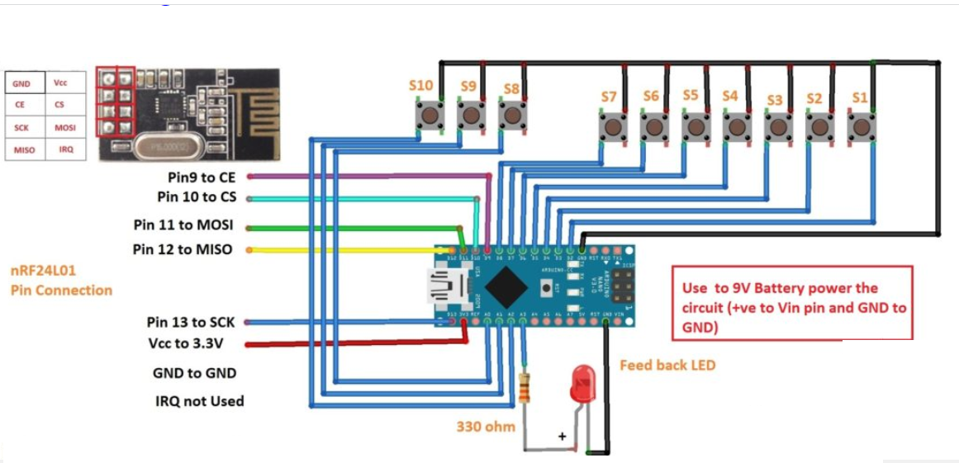

**Receiver**

